38.7: a) 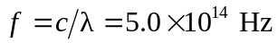
b) Each photon has energy 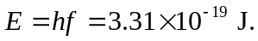
Source emits
c) No, they are different. The frequency depends on the energy of each photon and the number of photons per second depends on the power output of the source.

